

PROJECT REPORT
ON
PYTHON PROGRAMMING
SkillTrack – A Python-Based Learning Progress Analytics Dashboard
Submitted by
Anjali kumari(26MCD10064)
In partial fulfilment for the award of the degree of
Masters Of Computer Applications
In
Data Science

2026-28

BONAFIED CERTIFICATE
2026-28
This is to certify that the mini project report entitled “SkillTrack – Learning Progress Analytics Dashboard” is a record of the project work carried out by Anjali Kumari(26MCD10064), a student of Master of Computer Applications (MCA), Class/Section 2A, under the guidance and supervision of the undersigned.
The project has been developed using Python and its supporting libraries to demonstrate the design and implementation of an interactive learning analytics dashboard.
The work presented in this report is suitable for academic evaluation as a Python mini project.
To the best of our knowledge, the work embodied in this report has been completed by the student and has not been submitted elsewhere for the award of any other degree or qualification.
SIGNATURE: SIGNATURE:
Name : Anjali kumari NAME : Er.Prabhjot kaur
UID :26MCD10064 (E17274)

DECLARATION
I hereby declare that the mini project entitled “SkillTrack – Learning Progress Analytics Dashboard” has been developed by me as part of the academic requirements of the Master of Computer Applications programme.
The project is based on my learning and practical implementation of Python programming, data handling, data visualization, dashboard development, and database management.
This report has been prepared to describe the project objectives, design, implementation, testing, results, and future scope.
I declare that the work is original to the best of my knowledge. Wherever concepts, tools, or technical references have been used, they have been acknowledged in the references section.
I understand that the project may be reviewed for academic purposes.
Name: Anjali Kumari
Programme: Master of Computer Applications
Class / Section: MCA – 2A
Signature: ______________________
Date: ___________________________

ACKNOWLEDGEMENT
I would like to express my sincere gratitude to my faculty members and project guide for their valuable guidance, encouragement, and support during the development of SkillTrack – Learning Progress Analytics Dashboard.
I am thankful to the Department of Computer Applications, Chandigarh University, for providing an academic environment that encourages practical learning and project-based understanding.
The opportunity to work on this project helped me connect programming concepts with a useful real-world application.
I also acknowledge the developers and documentation teams of Python, Streamlit, Pandas, Plotly, and SQLite. Their tools and learning resources made it possible to implement the dashboard, organize data, create interactive visualizations, and store information efficiently.
Finally, I am grateful to my family and friends for their encouragement and motivation throughout the completion of this project.
Name : Anjali kumari
UID : 26MCD10064

ABSTRACT
SkillTrack – Learning Progress Analytics Dashboard is a Python-based mini project designed to help learners organize their courses, monitor progress, and review study activity through a single interactive interface.
Students often learn through multiple courses and resources, but their progress may be scattered across notebooks, spreadsheets, and online platforms. SkillTrack provides a simple way to maintain course details and visualize learning activity.
The application is developed using Streamlit for the user interface, Pandas for tabular data handling, Plotly for interactive charts, and SQLite for persistent storage.
The dashboard displays summary indicators such as total courses, completed courses, ongoing courses, learning hours, and average progress. Course management features allow users to add, update, search, and delete courses. A learning log records the course, date, and number of study hours.
The system presents course completion status, course-wise progress, and weekly learning hours through visual charts. The project demonstrates how Python libraries can be combined to build a functional data-driven dashboard without requiring a separate front-end framework.
The result is a practical, beginner-friendly application that supports self-monitoring and can be extended with reminders, authentication, export options, and richer analytics.
Keywords: Python, Streamlit, Pandas, Plotly, SQLite, Dashboard, Learning Analytics, Data Visualization.

TABLE OF CONTENTS
S. No. | Chapter / Section | Page No.
1 | Introduction | 7
2 | Problem Statement and Objectives | 8
3 | Scope and Feasibility Study | 9
4 | Technology Stack | 10
5 | System Requirements | 11
6 | System Analysis and Design | 12
7 | Database Design | 13
8 | Implementation | 14
9 | Dashboard Modules and Visualizations | 15
10 | Testing and Results | 16
11 | Conclusion and Future Scope | 17
12 | References | 18

CHAPTER 1: INTRODUCTION
1.1 Background:
Digital learning has become common in academic and professional environments. Learners may enroll in programming, analytics, web development, database, and other courses at the same time.
Tracking course completion and time spent on learning helps students plan their work and identify areas that need attention.
A learning analytics dashboard can provide a clear overview of learning activities through numerical summaries and graphical representations.
1.2 Introduction to SkillTrack:
SkillTrack is a compact learning analytics application that provides a centralized dashboard for course information and study sessions.
Users can record a course title, category, estimated duration, and current completion percentage. The dashboard converts this information into summary cards and charts that are easy to understand.
The application also allows users to record their daily learning hours and review their learning history.
1.3 Motivation:
The motivation behind the project is to demonstrate a useful application of Python data tools while solving a familiar student problem.
Instead of maintaining separate manual records, a learner can enter information into one interface and see a visual overview of progress.
1.4 Project Overview:
SkillTrack consists of three main modules:
- Dashboard
- Manage Courses
- Learning Log
The application uses Python for its core functionality and SQLite for storing data locally.

CHAPTER 2: PROBLEM STATEMENT AND OBJECTIVES:
2.1 Problem Statement:
Students frequently study multiple subjects or online courses, but it can be difficult to maintain a clear view of completion status and learning time.
Manual tracking may become inconsistent, and raw records do not easily reveal weekly patterns or relative progress.
A simple application is needed to store course details and present meaningful summaries through graphs and dashboard metrics.
2.2 Aim:
The main aim of this project is to develop an interactive Python dashboard that enables learners to manage courses and analyze their learning progress using visualizations.
2.3 Objectives:
The main objectives of SkillTrack are:
- To create a user-friendly dashboard interface using Streamlit.
- To store course records and study sessions in an SQLite database.
- To provide options to add, update, search, and delete courses.
- To calculate total courses, completed courses, ongoing courses, and average progress.
- To record daily study sessions and calculate total learning hours.
- To visualize completion status, course-wise progress, and weekly study hours.
- To demonstrate the integration of Python data-processing and visualization libraries.
2.4 Expected Outcome:
The expected outcome is a working local web dashboard that presents course information in a structured and visual manner.
The application is intended as a learning-support tool and does not claim to measure the quality of learning or academic achievement automatically.

CHAPTER 3: SCOPE AND FEASIBILITY STUDY:
3.1 Project Scope:
The project focuses on individual learning records. Users can maintain course information, update progress percentages, and log time spent studying.
Dashboard visualizations are generated from the stored records. The application is suitable for demonstration, personal tracking, and introductory data analytics practice.
3.2 In-Scope Features:
The following features are included in the project:
- Local course management and learning-session recording.
- Progress metrics and interactive charts.
- Search and course selection controls.
- Persistent storage through a local SQLite database.
- A browser-based interface launched from a Python environment.
3.3 Out-of-Scope Features:
The following features are not included in the current version:
- Multi-user login and role-based permissions.
- Cloud synchronization and online backup.
- Automated integration with external learning platforms.
- AI-generated course recommendations.
- Mobile application development.
3.4 Feasibility Study:
Technical Feasibility:
Python, Streamlit, Pandas, Plotly, and SQLite are suitable for a small interactive data application. These technologies provide the required tools for interface development, data processing, visualization, and storage.
Economic Feasibility:
The selected technologies are available without paid licenses for this project. Therefore, the development cost is minimal.
Operational Feasibility:
The interface uses familiar forms, navigation controls, and charts. A student can operate the application with minimal training.
3.5 Limitations:
The dashboard depends on accurate user-entered data. Progress values and study hours are not independently verified. The application is designed for local use and does not provide authentication or cloud backup.
CHAPTER 4: TECHNOLOGY STACK:
4.1 Introduction:
SkillTrack is developed using Python and its supporting libraries. Each technology performs a specific function in the application, including interface development, data handling, visualization, and database management.
4.2 Python:
Python is a high-level, interpreted programming language known for its simple syntax and readability.
It is widely used in data analysis, web development, automation, and artificial intelligence.
In SkillTrack, Python is used to implement the application logic, database operations, calculations, and interaction between different modules.
4.3 Streamlit:
Streamlit is an open-source Python framework used to create interactive web applications.
It provides components such as buttons, forms, input fields, sliders, metrics, and charts.
In SkillTrack, Streamlit is used to create the dashboard interface and provide navigation between different modules.
4.4 Pandas:
Pandas is a Python library used for data manipulation and analysis.
It provides DataFrames that allow data to be organized in rows and columns.
In SkillTrack, Pandas is used to retrieve database records, calculate learning statistics, and group study hours by date.
4.5 Plotly:
Plotly is a data visualization library used to create interactive graphs and charts.
The project uses Plotly Express to create:
- Course Completion Status Pie Chart
- Weekly Learning Hours Bar Chart
- Course-wise Progress Bar Chart
4.6 SQLite:
SQLite is a lightweight relational database management system.
It stores information in a local database file and does not require a separate database server.
In SkillTrack, SQLite stores course information and learning-session records.
4.7 Visual Studio Code:
Visual Studio Code is used as the code editor for developing and executing the project.
It provides a terminal, syntax highlighting, debugging support, and Python extensions.
4.8 Web Browser:
The SkillTrack application runs locally and is displayed through a web browser such as Google Chrome or Microsoft Edge.

CHAPTER 5: SYSTEM REQUIREMENTS:
5.1 Introduction:
System requirements describe the hardware and software resources needed to develop and execute the SkillTrack application.
The project is designed to run on a standard computer or laptop using Python and a modern web browser.
5.2 Hardware Requirements:
The following hardware configuration is recommended:
Hardware Component | Requirement
Processor | Intel Core i3 or equivalent
RAM | Minimum 4 GB
Storage | At least 200 MB free space
Display | Standard laptop or monitor display
Input Devices | Keyboard and mouse
5.3 Software Requirements:
Software | Purpose
Operating System | Windows, Linux, or macOS
Python 3.x | Application development
Visual Studio Code | Code editing
Streamlit | Dashboard interface
Pandas | Data processing
Plotly | Data visualization
SQLite | Database management
Google Chrome / Edge | Application execution
5.4 Installation Requirements:
The required Python libraries can be installed through the terminal using the following command:
py -m pip install streamlit pandas plotly
After installing the dependencies, the application can be executed using:
py -m streamlit run app.py
5.5 Project Structure:
The SkillTrack project contains the following main files:
- app.py – Main Python application file.
- skilltrack.db – SQLite database file created automatically.
- Other supporting files, if required.
The application creates the database when it is executed for the first time.
5.6 Execution Environment:
The application runs on the local computer. Streamlit starts a local web server and provides a URL that can be opened in a browser.
The user can interact with the dashboard through forms, navigation controls, and graphical visualizations.

CHAPTER 6: SYSTEM ANALYSIS AND DESIGN:
6.1 System Architecture:
SkillTrack follows a simple three-layer architecture. The architecture separates the user interface, application logic, and data storage.
The presentation layer is implemented using Streamlit components. The application layer contains Python functions for validation, calculations, course management, and learning-log operations. The data layer is an SQLite database.
This structure makes the application easier to understand, maintain, and extend.
6.2 Presentation Layer:
The presentation layer is responsible for displaying the dashboard and accepting user input.
It includes:
- Sidebar navigation.
- Course management forms.
- Learning log forms.
- Dashboard metrics.
- Interactive graphs and charts.
6.3 Application Layer:
The application layer contains the main Python functions.
It performs the following operations:
- Validates user input.
- Adds, updates, and deletes course records.
- Records learning sessions.
- Calculates learning statistics.
- Retrieves data for dashboard visualizations.
6.4 Data Layer:
The data layer uses SQLite to store course information and learning sessions.
It provides persistent storage so that records remain available even after the application is closed.
6.5 Data Flow:
When a user enters information into the dashboard, the application processes the input and stores it in the database.
The dashboard retrieves the updated information, performs calculations using Pandas, and generates visualizations using Plotly.
6.6 Navigation Design:
The application contains three main modules:
- Dashboard
- Manage Courses
- Learning Log
The sidebar allows users to move between these modules easily.

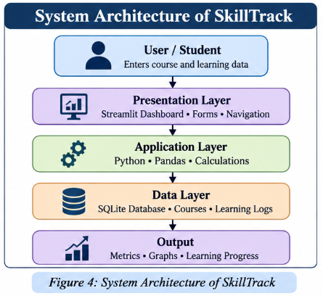

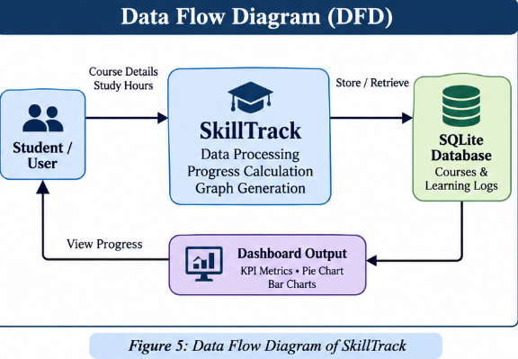
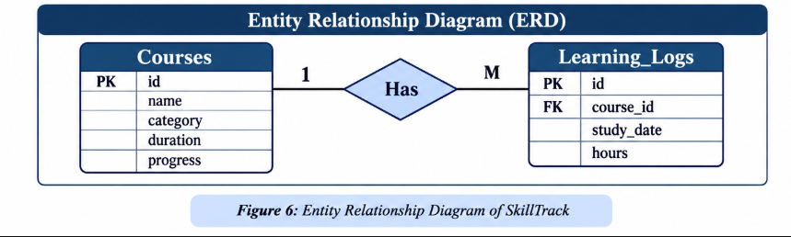
CHAPTER 7: SYSTEM IMPLEMENTATION:
7.1 Introduction:
The implementation phase converts the system design into a working application. SkillTrack is implemented using Python and Streamlit. It provides an interactive dashboard for managing courses and recording learning activities.
The application stores course details and learning logs in an SQLite database. Pandas is used to process and organize data, while Plotly is used to create interactive visualizations.
7.2 Modules of the System:
The SkillTrack application consists of the following modules:
1. Dashboard Module
This module displays an overview of the user's learning progress. It includes total courses, completed courses, total learning hours, and progress charts.
2. Course Management Module
This module allows users to add and manage courses. Course details include course name, category, duration, and progress.
3. Learning Log Module
This module records learning activities such as study date, course name, and number of hours spent studying.
4. Data Visualization Module
This module represents learning data using charts and graphs. It helps users understand their progress and study patterns.
5. Database Module
SQLite is used to store course information and learning logs. The stored data can be retrieved whenever the dashboard is opened.
7.3 Implementation Workflow:
The application follows these steps:
- The user opens the SkillTrack dashboard.
- The user adds course details.
- The user records learning activities.
- The application stores the information in SQLite.
- Python processes the stored data.
- The dashboard displays updated metrics and charts.
CHAPTER 8: GRAPHICAL REPRESENTATION AND RESULTS:
8.1 Introduction:
Data visualization is an important feature of SkillTrack. It converts learning information into graphical representations that are easy to understand. The dashboard uses interactive charts to display course progress and study activities.
8.2 Course Progress Chart:
The course progress chart represents the completion percentage of different courses. It helps users compare their progress across multiple learning subjects.
Figure 7: Course Progress Visualization
📌 Add Screenshot: Take a screenshot of the course progress chart from your SkillTrack dashboard and paste it here.
8.3 Learning Hours Chart:
The learning hours chart displays the time spent studying. It helps users understand their study patterns and identify how much time they dedicate to learning.
Figure 8: Learning Hours Visualization
📌 Add Screenshot: Paste the learning hours chart screenshot from your dashboard here.
8.4 Dashboard Output:
The dashboard provides a summarized view of the learning activities. It displays important performance indicators and graphical reports in a single interface.
The main output includes:
- Total number of courses
- Completed courses
- Total learning hours
- Course progress chart
- Learning hours chart
CHAPTER 9: TESTING AND VALIDATION:
9.1 Introduction:
Software testing is performed to verify that the application works correctly and meets its requirements. SkillTrack is tested by checking its main features, data entry, database operations, and dashboard output.
9.2 Test Cases:
Test Case | Expected Result | Status
Open SkillTrack dashboard | Dashboard opens successfully | Pass
Add a new course | Course is stored in database | Pass
Record learning hours | Learning log is saved | Pass
View course progress | Progress chart is displayed | Pass
View learning hours | earning hours chart is displayed | Pass
Retrieve saved data | Stored information is displayed | Pass
9.3 Testing Result:
The application was tested using sample course details and learning activities. The dashboard displayed the stored information and generated visualizations based on the available data.
The testing process confirms that the main features of SkillTrack function as expected.
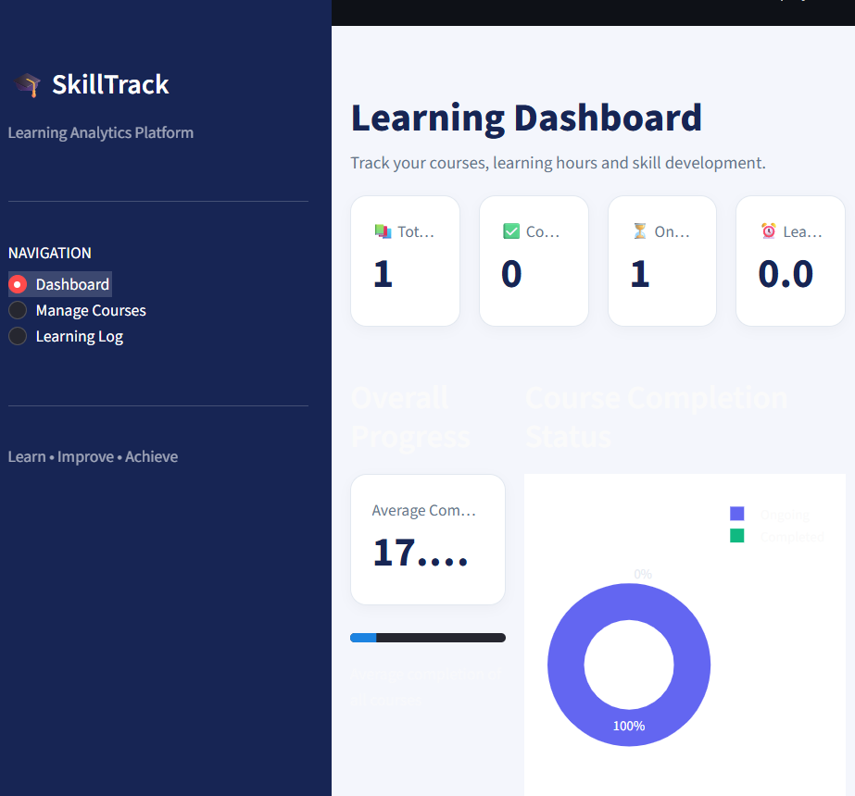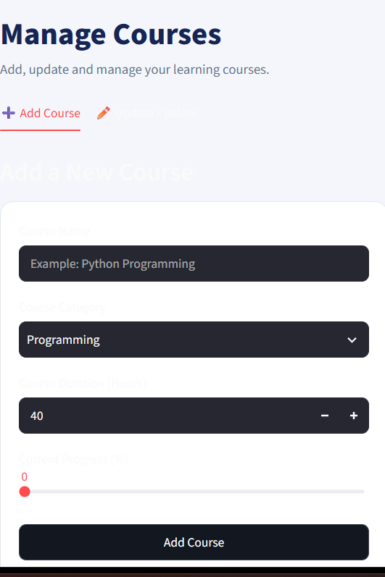

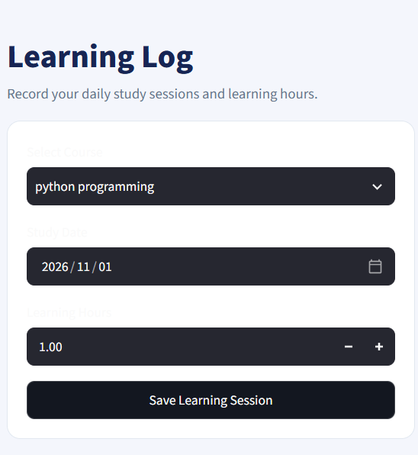
CHAPTER 10: CONCLUSION AND FUTURE SCOPE:
10.1 Conclusion:
SkillTrack is a Learning Progress Analytics Dashboard developed using Python. The main purpose of this project is to help users manage their courses, record learning activities, and monitor their learning progress.
The application provides an interactive dashboard with metrics and graphical representations. SQLite is used for data storage, Pandas is used for data processing, and Plotly is used for visualization.
This project helped in understanding the practical implementation of Python libraries, database connectivity, data analysis, and dashboard development.
10.2 Future Scope:
The project can be enhanced in the future by adding the following features:
- User login and authentication
- Exporting reports in PDF or Excel format
- Weekly and monthly progress reports
- Learning goals and reminders
- Advanced analytics and performance prediction
- Cloud database integration
- Improved dashboard customization
These features can make SkillTrack more useful and efficient for learning progress management.

REFERENCES:
This project, titled “SkillTrack – Learning Progress Analytics Dashboard,” has been developed as part of my academic mini-project for the MCA programme.
The project is designed and implemented using Python, Streamlit, Pandas, Plotly, and SQLite. I have worked on the development of the application, dashboard design, database integration, and graphical representation of learning progress.
This project helped me enhance my programming skills and gain practical knowledge of Python-based application development.
Submitted By: Anjali Kumari
Programme: MCA(Data Science)
Section: 2A

